**Software Requirement Specification(SRS)**

**for**

**Online Library Management(OLM)**

Prepared by

**Ankita Pandey**

Proposed to

**Geethanjali Anbalagan**

**10-03-2022**

Contents

1. **Introduction**

1.1 Purpose

* 1. Scope
  2. Audience, Definitions, Acronyms and Abbreviations
  3. References
  4. Overview

**2. Overall Description**

2.1 Product Perspective

2.2 Software Requirements

2.3 Hardware Requirements

2.4 Assumptions and dependencies

**3. Specific Requirements**

3.1 Functional Requirements

3.2 Non-functional Requirements

3.2.1 Performance Requirements

3.2.2 Safety Requirements

3.2.3 Security Requirements

3.2.4 Error handling

**4. Flowchart**

**1. INTRODUCTION**

**1.1 Purpose**

This document is meant to delineate the features of OLM, so as to serve as a guide to the developers on one hand and a software validation document for the prospective client on the other. The main objective of this document is to illustrate the requirements of the project Library Management system. The purpose of this project is to provide a friendly environment to maintain the details of books and library members. The main purpose of this project is to maintain easy circulation system using computers and to provide different reports.

**1.2 Scope**

The software will reflect all the requirements defined by the customer. College Library

Management System will allow to perform all necessary procedures for librarians and patrons.

According

**Initial functional requirements will be: -**

* Secure registration and profile management facilities for users
* Browsing through the e-store to see the books.
* Adequate searching mechanisms for easy and quick access to particular book
* Creating a Shopping cart so that users can shop ‘n’ no. of items and checkout finally with the entire shopping carts. Customers can add or delete items in the cart.
* Regular updates to registered customers of the OLM about new arrivals.
* Uploading ‘Most Read’ books in each category of products in the Shop.
* Maintaining database of regular users of different needs.
* Adequate payment mechanism and gateway for all popular credit cards, cheques and other relevant payment options, as available from time to time.

**Initial non-functional requirements will be: -**

* Secure access of confidential data (user’s details).
* 24 X 7 availability
* Better component design to get better performance at peak time
* Advertisement space where it will effectively catch the customer’s attention and as a source of revenue.
* Warehousing within the very ambits of the project
* More payment gateways for book renting.

Scope of Development Project Library Management System is basically updating the manual library system into an internet-based application so that the users can know the details of their accounts, availability of books and maximum limit for borrowing. The project is specifically designed for the use of librarians and library users. The product will work as a complete user interface for library management process and library usage from ordinary users. Library Management System can be used by any existing or new library to manage its books and book borrowing, insertion and monitoring. It is especially useful for any educational institute where modifications in the content can be done easily according to requirements. The project can be easily implemented under various situations. We can add new features as and when we require, making reusability possible as there is flexibility in all the modules. The language used for developing the project is Java as it is quite advantageous than other languages in terms of performance, tools available, cross platform compatibility, libraries, cost (freely available), and development process.

**1.3 Definitions, Acronyms and Abbreviations**

JAVA -> platform independence

SQL-> Structured query Language

ER-> Entity Relationship

IDE-> Integrated Development Environment

SRS-> Software Requirement Specification

**1.4 References**

* IEEE 830-1998 standard for writing SRS document.

**1.5 Overview**

The implementation of Library Management starts with entering and updating master records like book details, library information. Any further transaction like book issue, book return will automatically update the current book.

1. **Overall Description**

**2.1 Product Perspective**

Online Library Management is a replacement for the ordinary library management systems which depend on paper work

Chapter 2

Overall Description

2.1 Product Perspective

LMS is a replacement for the ordinary library management systems which depend on paper

work for recording book and users’ information.

LMS will provide an advanced book search mechanism and will make it easy to borrow, insert

and index a book in the librar

Chapter 2

Overall Description

2.1 Product Perspective

LMS is a replacement for the ordinary library management systems which depend on paper

work for recording book and users’ information.

LMS will provide an advanced book search mechanism and will make it easy to borrow, insert

and index a book in the librar

The system provides different types of services based on the type of users [Member/Librarian]. The Librarian will be acting as the controller and he will have all the privileges of an administrator. The member can be either a student or staff of the university who will be accessing the Library online. The features that are available to the Librarian are: -

* A librarian can issue a book to the member.
* Can view the different categories of books available in the Library
* Can view the List of books available in each category
* Can take the book returned from students
* Add books and their information to the database
* Edit the information of existing books
* Can check the report of the existing books
* Can check the report of the issued books
* Can access all the accounts of the students.

The features that are available to the Members are: -

* Can view the different categories of books available in the Library
* Can view the List of books available in each category
* Can own an account in the library.
* Can view the books issued to him
* Can put a request for a new book
* Can view the history of books issued to him previously
* Can search for a particular book

**2.2 SOFTWARE REQUIREMENT**

Front end:

* Android developer tool
* Advance java

Back end:

* MySQL

**2.3 HARDWARE REQUIREMENT**

* Android version 2.3 ginger bread (minimum, android user’s)
* 2GB ram
* 1.2 GHz processor
* Intel i5
* Windows 7/8/8.1/10

Chapter 2

Overall Description

2.1 Product Perspective

LMS is a replacement for the ordinary library management systems which depend on paper

work for recording book and users’ information.

LMS will provide an advanced book search mechanism and will make it easy to borrow, insert

and index a book in the librar

**2.4 Assumptions and Dependencies**

The assumptions are: -

* The coding should be error free
* The system should be user-friendly so that it is easy to use for the users
* The information of all users, books and libraries must be stored in a database that is accessible by the website
* The system should have more storage capacity and provide fast access to the database
* The system should provide search facility and support quick transactions
* The Library System is running 24 hours a day
* Users may access from any computer that has Internet browsing capabilities and an Internet connection
* Users must have their correct usernames and passwords to enter into their online accounts and do actions

The dependencies are: -

* The specific hardware and software due to which the product will be run
* On the basis of listing requirements and specification the project will be developed and run
* The end users (admin) should have proper understanding of the product
* The system should have the general report stored
* The information of all the users must be stored in a database that is accessible by the Library System
* Any update regarding the book from the library is to be recorded to the database and the data entered should be correct

1. **Specific Requirements**
   1. **Functional Requirements**

In this system there are lots of functioning.

* The user can Search book and see his/her account information.
* He will be able to get the records in any format.
* There will also be a reminder and digital diary through this he can go to know about
* its important date like his book submission date.
* Admin can add new record and saw all record of any student as well as library.
* **Register**

Description: First the user will have to register/sign up. There are two different type of users.

The library manager/head: The manager has to provide details about the name of library, address, phone number, email id.

Regular person/student: The user has to provide details about his/her name of address, phone number, email id.

* **Sign up**

Input: Detail about the user as mentioned in the description.

Output: Confirmation of registration status and a membership number and password will be generated and mailed to the user.

Processing: All details will be checked and if any error is found then an error message is displayed else a membership number and password will be generated.

* **Login**

Input: Enter the membership number and password provided.

Output: User will be able to use the features of software.

* **Manage books by user.**
* **Books issued**

Description: List of books will be displaced along with data of return

* **Search**

Input: Enter the name of author's name of the books to be issued.

Output: List of books related to the keyword.

* **Issues book**

State: Searched the book user wants to issues

Input: click the book user wants.

Output: conformation for book issue and apology for failure in issue.

Processing: if selected book is available then book will be issued else error will be displayed.

* **Renew book**

State: Book is issued and is about to reach the date of return.

Input: Select the book to be renewed.

Output: conformation message.

Processing: If the issued book is already reserved by another user then error message willbe send and if not then conformation message will be displayed.

* **Return**

Input; Return the book to the library.

Output: The issued list will be updated and the returned book will be listed out.

* **Reserve book**

Input; Enter the details of the book.

Output: Book successfully reserved.

Description: If a book is issued by someone then the user can reserve it, so that later the user can issue it.

* **Fine**

Input: check for the fines.

Output: Details about fines on different books issued by the user.

Processing: The fine will be calculated, if it crossed the date of return and the user did not renew if then fine will be applied by Rs. 20 per day.

* **Manage book by librarian**
* **Update details of books**
* **Add books**

Input: Enter the details of the books such as names, author, edition, quantity.

Output: confirmation of addition.

* **Remove books**

Input: Enter the name of the book and quantity of books.

Output: Update the list of the books available.

**Module Description**

**Type of user**

* Administrator (librarian)
* HOD of all Department
* Student
* Faculty
* Staff

**Administrator module:**

* Budget (for all department)
* Stock verification
* Create user
* Accept/Reject user
* Change password
* Book inventory
* User information
* Report generation
* Search Book

**Complaint**

* All user can send their complaint

**User module**

* Change password
* Book Search
* See account information

**Fine information**

* All user checks their fine
* Fine by date & Month

**Book inventory**

* Purchasing book information
* Maintain book inventory

**Book search**

* Normal search by alphabet
* Quick search by type (Book id, Author, ISBN, Publication)
  1. **Non- Functional Requirements**

Following Non-Functional Requirements will be there in the insurance to the internet:

1. Secure access to user’s confidential data.
2. 24X7 availability.
3. Better component design to get better performance at peak time.
4. Flexible service based architecture will be highly desirable for future extension.
5. Non-Functional Requirements define system properties and constraints. Various other Non-Functional Requirements are:

* Security
* Reliability
* Maintainability
* Portability
* Extensibility
* Reusability
* Compatibility
* Resource Utilization
* Response time

**Performance Requirements**

* This software is not breakdown suddenly in any disaster like power failure.
* The development of the software will be based on the object oriented model.
* The timeline of this software must be in our mind.
* The performance of the functions and every module must be well.
* At every step the output of the one phase is the input of the other phase and it will be

reliable and accurate.

* The risk factor must be taken at initial step for better performance of the software.
* For individual function the performance will be well.
* For login to the software password and user name will be matched to the password

and name

* saved in the database and thus only authenticated users are allowed to the login.
* There will be various ways of retrieving data and it takes less time.
* There will be ambiguity in the data and the record.

**Safety Requirement**

* The database may get crashed at any certain time due to virus or operating system failure. Therefore, it is required to take the database backup so that the database is not lost. Proper UPS/inverter facility should be there in case of power supply failure.

**Security Requirement**

* System will use secured database
* Normal users can just read information but they cannot edit or modify anything except their personal and some other information.
* System will have different types of users and every user has access constraints
* Proper user authentication should be provided
* No one should be able to hack users’ password
* There should be separate accounts for admin and members such that no member can access the database and only admin has the rights to update the database.

**Error Handling**

* LMS product shall handle expected and unexpected errors in ways that prevent loss in information and long downtime period.

Chapter 4

Nonfunctional Requirements

4.1 Performance Requirements

•The system shall accommodate high number of books and users without any fault.

•Responses to view information shall take no longer than 5 seconds to appear on the

screen.

4.2 Safety Requirement

Chapter 4

Nonfunctional Requirements

4.1 Performance Requirements

•The system shall accommodate high number of books and users without any fault.

•Responses to view information shall take no longer than 5 seconds to appear on the

screen.

4.2 Safety Requirement

1. **Flow chart**

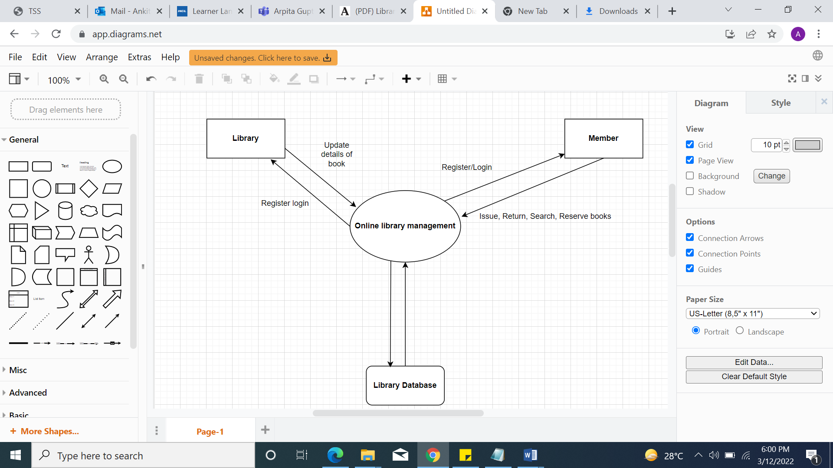

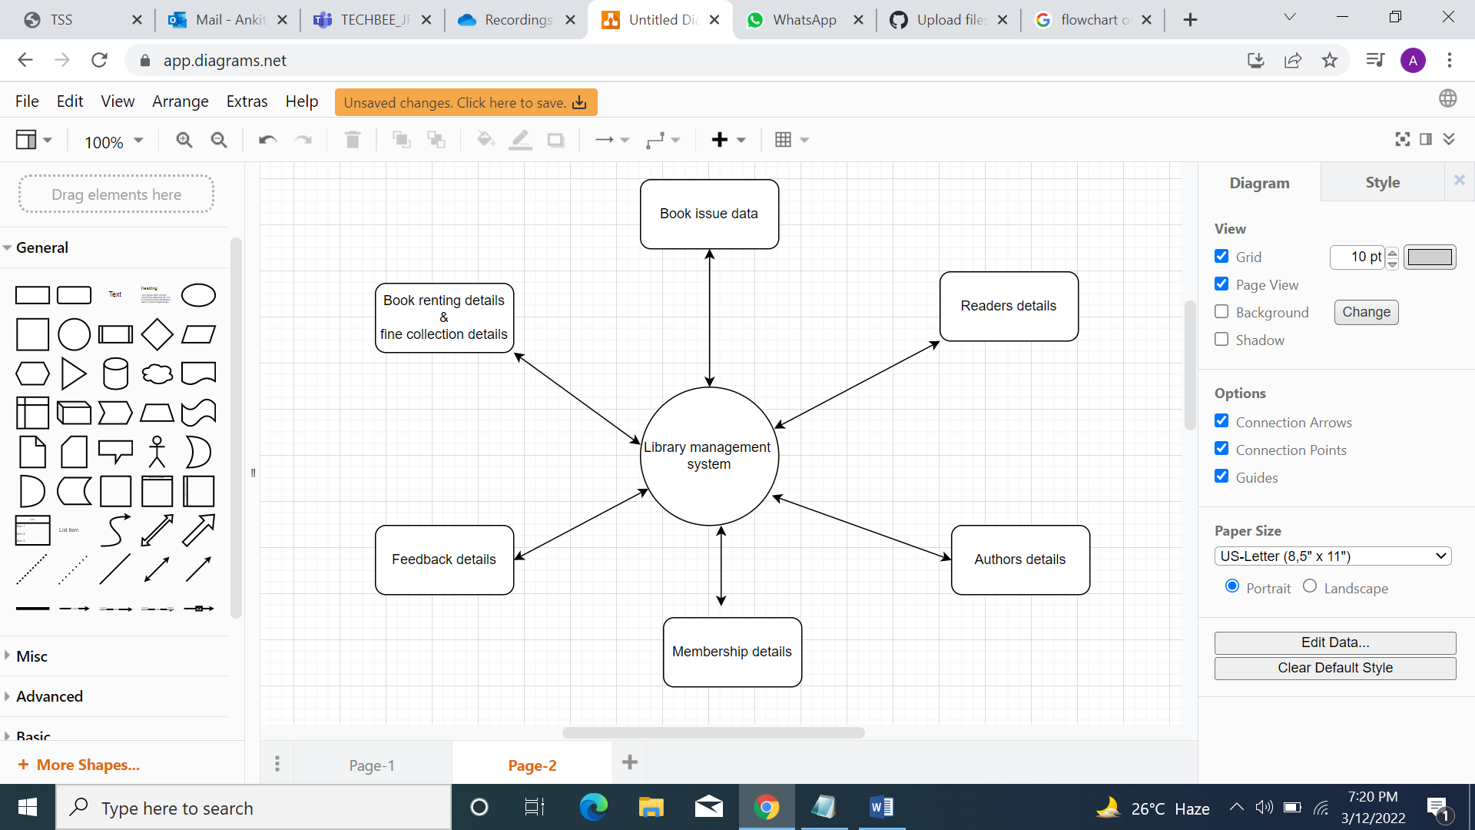

Chapter 1

Introduction

1.1 Purpose

The purpose of this document is to familiarize reader with software. Specification describes all

hardware and software requirements for product, behavior of it and its components. Software

Requirements Specification (SRS) allows to verify the customer that all his requirements are

observed and implemented correctly by de- veloper.

The intended audience for the SRS reading consists of system end-users (patrons), customer

engineers, software developers.

1.2 Scope

The software will reflect all the requirements defined by the customer. College Library

Management System will allow to perform all necessary procedures for librarians and patrons.

According to customer requirements the software to be developed will consist of three

databases:

•Item’s database (books, journals, magazines, newspapers, diploma thesis, etc)

•Patron’s database

•a small Access-based database with information about digital items, that College has

(software, music) integrated with Item’s database

LMS will also provide all necessary services for databases such as creating, deleting, updating

and searching information. Patrons will be able to access to the library site (web-based)

through the Internet

Chapter 1

Introduction

1.1 Purpose

The purpose of this document is to familiarize reader with software. Specification describes all

hardware and software requirements for product, behavior of it and its components. Software

Requirements Specification (SRS) allows to verify the customer that all his requirements are

observed and implemented correctly by de- veloper.

The intended audience for the SRS reading consists of system end-users (patrons), customer

engineers, software developers.

1.2 Scope

The software will reflect all the requirements defined by the customer. College Library

Management System will allow to perform all necessary procedures for librarians and patrons.

According to customer requirements the software to be developed will consist of three

databases:

•Item’s database (books, journals, magazines, newspapers, diploma thesis, etc)

•Patron’s database

•a small Access-based database with information about digital items, that College has

(software, music) integrated with Item’s database

LMS will also provide all necessary services for databases such as creating, deleting, updating

and searching information. Patrons will be able to access to the library site (web-based)

through the Interne